Step 1 :- Click on Start 🡪 Click on Control Pannel

🡪 Click On Administrative Tools

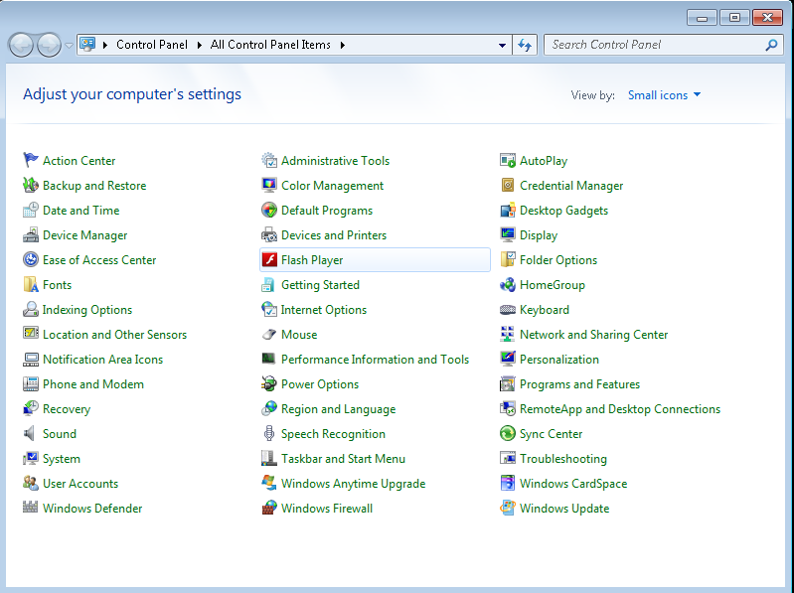

Step 2:- Administrative Tools Widow

🡪Click On Task Scheduler

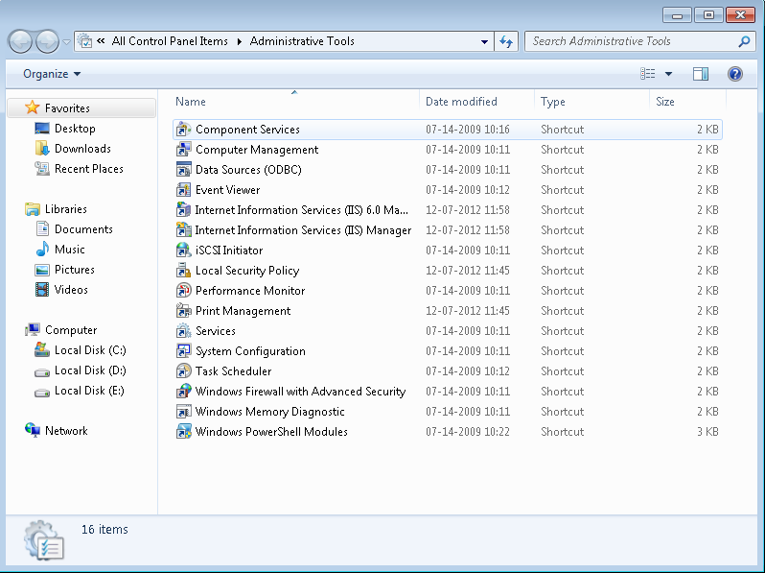

Step 3:- Task Scheduler Widow

🡪Click On Basic Task to add new task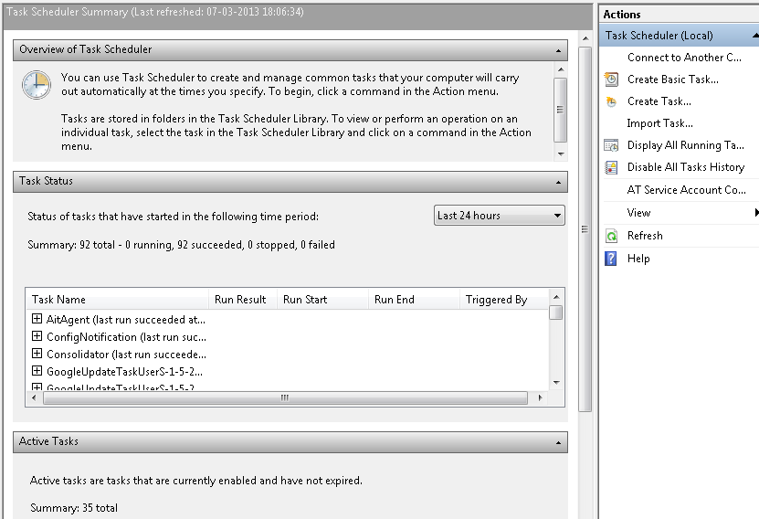

Step 4:- Basic Task Widow 🡪 Add Task Name and Description.

🡪Click On next

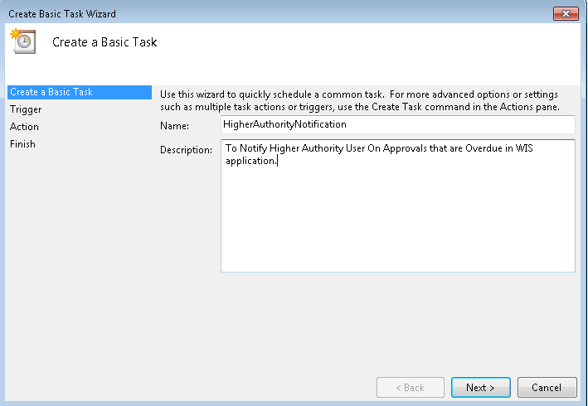

Step 5:- Basic Task Widow (Task Trigger) 🡪 Choose trigger type

🡪Click On next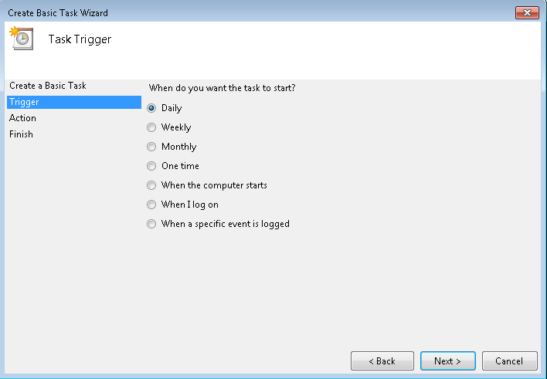

Step 6:- Basic Task Widow (Daily) 🡪 Set the Start Date and Time

🡪Click On next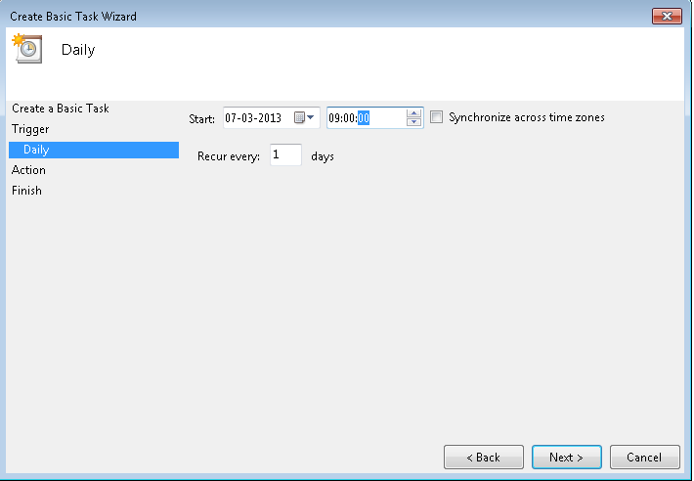

Step 7:- Basic Task Widow (Action) 🡪 Choose task type

🡪Click On next

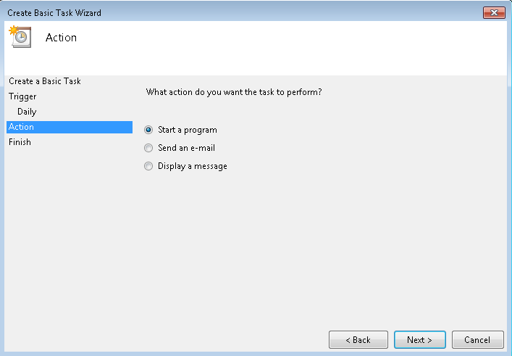

Step 8:- Basic Task Widow (Start a Program) 🡪 Browse Exe file

🡪Click On next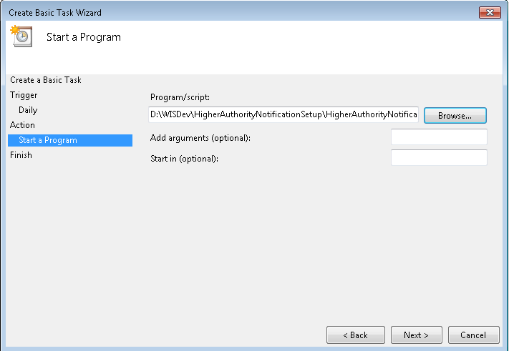

Step 9:- Basic Task Widow (Summary)

🡪Click On Finish

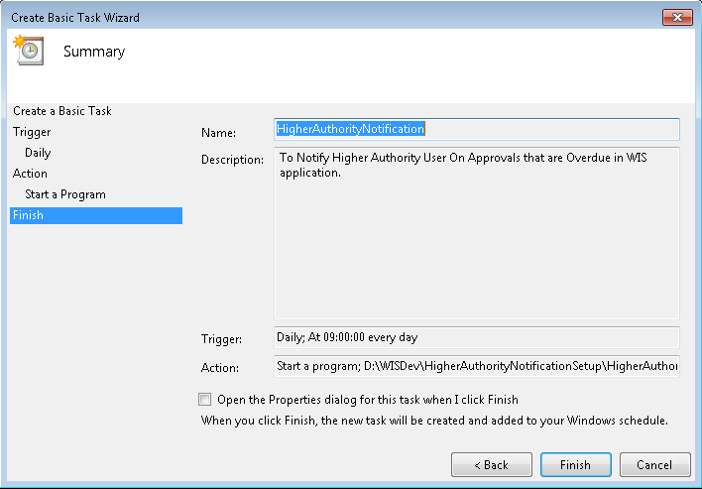

Your Task Scheduler is created.

